Herman Warrenburg
March 23, 1917 – May 5, 1999

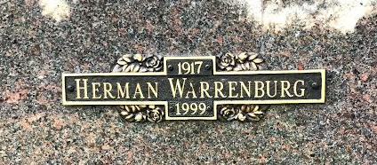
Photo by SMMR

Indiana, U.S., Death Certificates, 1899-2017
Name Herman Warrenburg
Gender Male
Race White
Marital Status Married
Age 82
Birth Date 23 Mar 1917
Birth Place Indianapolis, Indiana
Death Date 5 May 1999
Death Place Bluffton, Wells, Indiana, USA
Death Registration Date 1999
Father Herman Warrenburg
Mother Goldie Gilbreath
Spouse Wanda Butcher Warrenburg, informant
Burial 5/8/1999 Northridge Garden Crypt Mausoleum

