Isca (Wentz) Walmer
September 23, 1870 – October 10, 1936

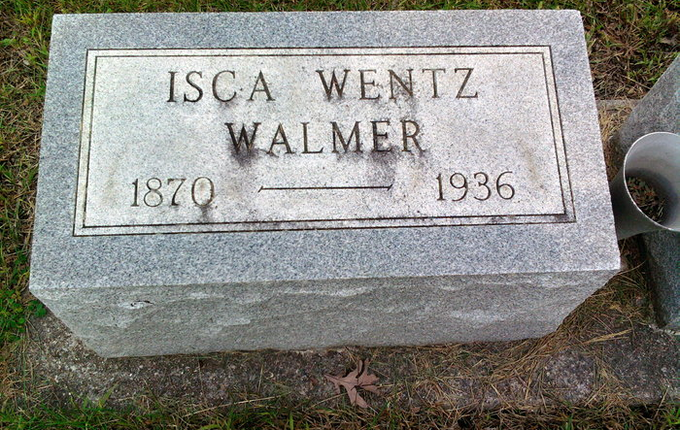
Photo by Thomas Liby

WALMER

Bluffton, Oct. 26 - Mrs. Isca Walmer, 66, wife of Edward S. Walmer, died today at her home here following an illness of three years of complications. Her marriage took place in this city on July 13, 1892.
Surviving are the husband, a son, Hillard, of Culver and a sister, Mrs. Augusta Stevens, of Detroit.
Mrs. Walmer was a member of the Universalist Church.
Funeral services will be held at the home at 2 pm Wednesday, with Rev. P. B. Smith in charge. Interment will be in the Fairview Cemetery.

Fort Wayne Journal-Gazette, Allen County, Indiana
October 23, 1936, Page 10
**

Indiana, U.S., Death Certificates, 1899-2017
Name Osca Walmer
[Osca Wentz]
Gender Female
Race White
Marital Status Married
Age 66y 0m 29d
Birth Date 23 Sep 1870
Birth Place Indiana
Death Date 19 Oct 1936
Death Place Bluffton, Wells, Indiana, USA
Death Registration Date 1936
Father William H Wentz
Mother Owega White
Spouse Edwin S Walmer, informant
Burial Fair View Cem 10/21/1936
**
Indiana, U.S., Marriages, 1810-2001
Name Isca Wentz
Gender Female
Race White
Event Type Marriage Registration (Marriage)
Birth Place Montpelier
Marriage Date 13 Jul 1892
Marriage Place Bluffton, Indiana, United States
Residence Place Bluffton
Father William N Wentz
Mother Owega J White
Spouse Edward S Walmer
Page 92

