Edwin Shuey Walmer
November 5, 1868 – February 19, 1941

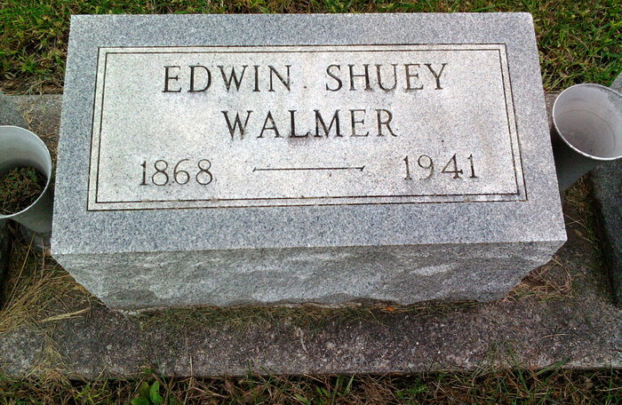
Photo by Thomas Liby

Prominent Bluffton Business Man Dies

Edwin S. Walmer, 72, for 50 years a prominent Bluffton business man, died late Wednesday afternoon at the Clinic hospital in that city, of heart disease.
Funeral services will be held at 2 p.m. Friday at the J. A. McBride & Son funeral home in Bluffton, with the body to be interred in the mausoleum at Fairview cemetery at Bluffton

Adams County (IN) Historical Museum
1941a Jan-June Scrapbook, image 032
Handwritten-Thurs. Feb. 20, 1941
**

Indiana, U.S., Death Certificates, 1899-2017
Name Edwin Walmer
Gender Male; Race White
Marital Status Married
Age 72y 3m 14d
Birth Date 5 Nov 1868; Birth Place Bluffton, Indiana
Death Date 19 Feb 1941; Death Place Bluffton, Wells, Indiana, USA
Father Herry Walmer
Mother Cathrene Krill
Spouse Mayne McConnel Walmer, age 52
Informant Col. H. W. Walmer, Camp Shelby, MS
Burial Fairview Mausoleum 2/21/1941

