Martin W. Walbert
January 3, 1860 – July 19, 1945

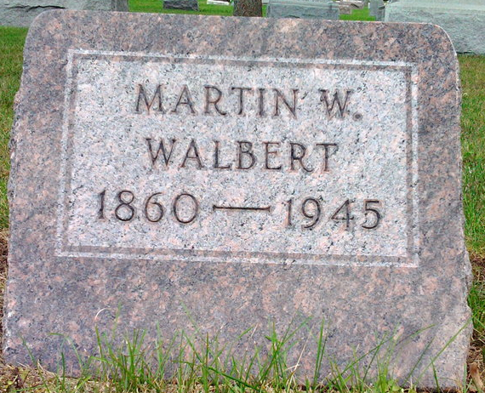
Photo by Thomas Liby

Indiana, U.S., Death Certificates, 1899-2017
Name Martin W Walbert
Gender Male
Race White
Marital Status Widowed
Age 85y 6m 16d
Birth Date 3 Jan 1860
Birth Place Dauphin County, Pennsylvania
Death Date 19 Jul 1945
Death Place Rural, Wells, Indiana, USA
Death Registration Date 1945
Father George Walbert
Mother Mary Wetzel
Spouse Emma Davis Walbert
Informant Herman Thomas
Burial 7/22/1945 Fairview Cemetery

