Emma (Davis) Walbert
July 15, 1867 – May 30, 1940

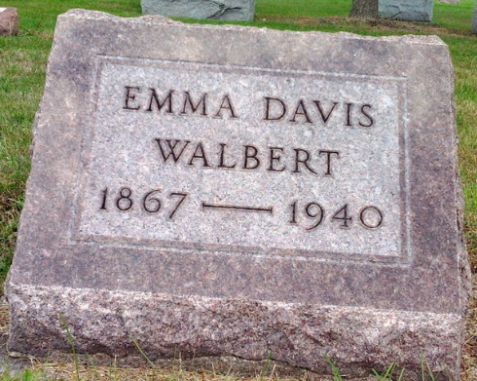
Photo by Thomas Liby
WALBERT

Bluffton, May 30 – Mrs. Emma Walbert, 72, wife of Martin W. Walbert, local attorney, died unexpectedly today at her home. Coroner William Gitlin, M.D., attributed death to a heart attack. Graduated from the Bluffton High School in 1884, Mrs. Walbert taught school eight years. She was a member of the library board here for 20 years.
Surviving are the husband; two sisters, Mrs. Amos Redding and Miss Ella Davis of Bluffton; a nephew, Milton Duff and a niece, Elizabeth Shady. She was a member of the First Baptist Church.
Funeral services will be held at 2:30 pm Saturday at the church. Rev. Morris Coers, the pastor, will be in charge and burial will be in Fairview Cemetery.

Journal-Gazette, Allen County, Indiana
May 31, 1940
**

Indiana, U.S., Death Certificates, 1899-2017
Name Mrs Emma Walbert [Mrs Emma Davis]
Gender Female; Race White
Marital Status Married
Age 72y 10m 15d
Birth Date 15 Jul 1867
Birth Place Wells County, Indiana
Death Date 30 May 1940
Death Place Bluffton, Wells, Indiana, USA
Father Millon M Davis
Mother Susan E Richey
Spouse Martin W Walbert, informant
Burial 6/1/1940 Fairview Cem

