Persephone Amelia Tucker
January 26, 2018 – March 27, 2018

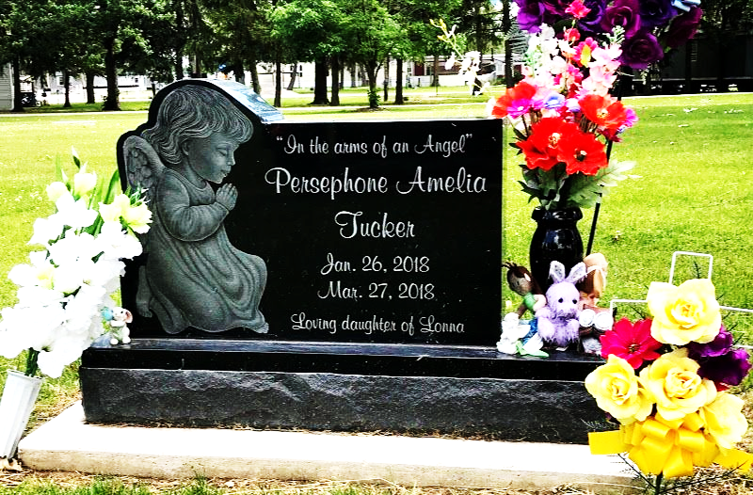
Photo by SMMR

Persephone Amelia Tucker (2 months old) went safely home to Jesus on Tuesday, March 27, 2018.
She was born January 26, 2018 in Huntington to Lonna Joan (Turner) Perkins. Persephone will be missed by her mother Lonna and siblings, Kyllie, Rosalie and Gabriel, all of Huntington. She is also survived by grandparents; Tamy Sult, Lonnie David Turner, Sr., and Anna Johnson, all of Huntington and Ronald Tucker of Ohio, along with many uncles, aunts and cousins of Indiana.
A service to celebrate her life will be held at 11 AM on Saturday at the Thoma/Rich, Lemler Funeral Home in Bluffton with Jeff Lemler officiating. Calling hours will be held from 9 to 11 A.M. on Saturday, prior to the service. Burial will follow at Fairview Cemetery in Bluffton. Memorials may be made the Persephone Tucker Fund at First Bank of Berne.
Thoma/Rich, Lemler Funeral Home, Wells County, Indiana
March 30, 2018

