Ralph Studabaker Todd
August 5, 1880 – April 1, 1927

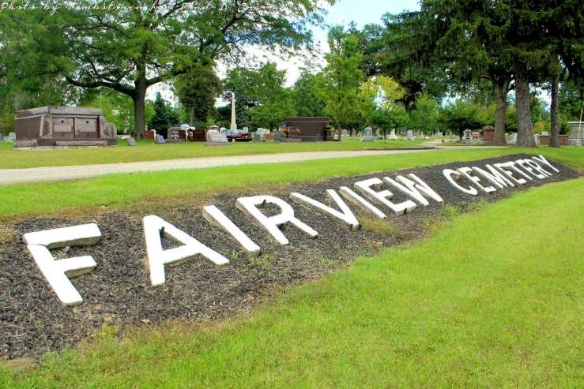
Photo by Tombstoner & Family

Ralph Studabaker Todd.

It is not necessary that the man who achieves success be made of sterner stuff than his fellow man, but there are certain indispensable characteristics that contribute to the prosperity of an individual; these are energy, ambition, determination and the ability to recognize and improve success. These qualities are cardinal elements in the character of Ralph Studabaker Todd and have accompanied him in his progress to a position of prominence and affluence. Mr. Todd is one of the substantial citizens of Bluffton and is president of the Studabaker Bank here.
Jacob Todd, grandfather of the subject of this review, was born in Beaver County, Pennsylvania, March 12, 1805, and his wife, whose maiden name was Jane Thomas, was a native of Columbiana County, Ohio, where her birth occurred January 2, 1807. <snip – see Jacob J., Todd Sr.]
Jacob J. Todd, son of Jacob and Jane (Thomas) Todd <snip – see Jacob J, Jr. & Mary Studabaker Todd] To this marriage were born two children: Mary and Ralph S. <snip]
Ralph S. Todd, born in Bluffton August 5, 1880, was graduated in the local high school in June, 1897, and in the fall of that year he entered DePauw University at Greencastle, Indiana, in which excellent institution he was graduated as a member of the class of 1901, with the degree of Bachelor of Philosophy. He initiated his business career as a bookkeeper in The Studabaker Bank in Bluffton, and in due time because assistant cashier and later cashier of that substantial financial institution. In June, 1909, he was chosen president of the bank and had the distinction of being the youngest man to hold such a position in the State of Indiana. He is still the efficient incumbent of that position, filling it with satisfaction to all and credit to him.
He is a director in the Studabaker Grain & Seed Company, Chairman of the Board of Directors of the W. B. Brown Company, director in the Bank of Petroleum and in the Fair View Cemetery Association and one of the trustees of DePauw University.
While a student in De Pauw University, Mr. Todd became acquainted with Miss Agnes Moulden, of Greenfield, Indiana, and his marriage to her was solemnized October 15, 1902. She was born in Marion County, Indiana, August 29, 1882. Mr. & Mrs. Todd have two children: James Moulden, born February 2, 1904; and Martha, born October 6, 1909. They are valued and appreciative members of the Methodist Episcopal Church, in which he is a member of the board of trustees.
Fraternally Mr. Todd is a thirty-second degree Mason, a member of Bluffton Commandery, Knights Templar, and of Mizpah Temple, Ancient Arabic Order of the Nobles of the Mystic Shrine. He is past chancellor of Bluffton Lodge No. 92, Knights of Pythias, and is connected with the Benevolent and Protective Order of Elks. He is a stalwart republican and was a delegate to the National Republican Convention in Chicago in 1916. As a loyal and public-spirited citizen Mr. Todd commands the unqualified esteem of his fellow men, and he is regarded as a substantial and influential factor in the civic and industrial life of Bluffton and of Wells County.

Standard History of Adams & Wells Counties, Indiana - 1918
Tyndall & Lesh

