Jacob Jefferson Todd, Sr.
March 12, 1805 – November 3, 1861

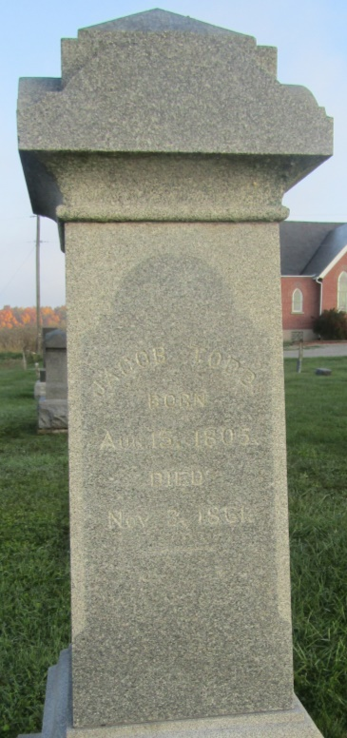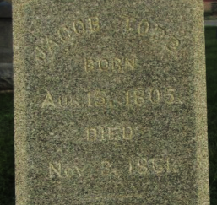

<snip>
Jacob Todd, grandfather of the subject of this review [Ralph Studabaker Todd], was born in Beaver County, Pennsylvania, March 12, 1805, and his wife, whose maiden name was Jane Thomas, was a native of Columbiana County, Ohio, where her birth occurred January 2, 1807. After their marriage they located on a farm in Beaver County, Pennsylvania, and there resided until 1851, when they came to Wells County, Indiana, and settled on a farm in section 19, Jefferson Township. The latter place was their home until their respective deaths, he passing away November 3, 1861, and she died June 5, 1888.
<snip>

Extracted from article on Ralph Studabaker Todd, Standard History of Adams & Wells Counties, Indiana, Tyndall & Lesh - – 1918

