Jacob Jefferson Todd, Jr.
March 12, 1843 – May 13, 1900

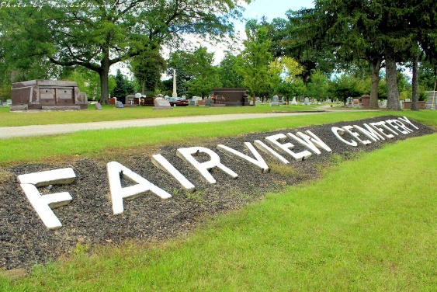
Photo by Tombstoner & Family

Reverting specifically to the life of Jacob Jefferson Todd, it is learned that he was born on the old family homestead in Beaver County, Pennsylvania, March 12, 1843. When less than eight years of age he came with his parents to Wells County, Indiana, and grew to maturity amid the pioneer scenes of Jefferson Township, lending in his youth effective assistance in clearing and improving the eighty acres which constituted the original farm. His preliminary educational advantages were such as the district schools afford, after which he was enabled to prosecute his studies for a time in Roanoke Seminary, Huntington, County, and still later in a college at Fort Wayne.
His was not a nature to tolerate subjective inactivity accordingly he forthwith proceeded to put his intellectual acquirements to a practical test by engaging in the work of teaching, a vocation to which he devoted his attention during the winter months from 1861 to 1866 inclusive, winning an enviable reputation as an able and popular educator. Essentially loyal and patriotic, Mr. Todd one of the first of Wells County's brave to respond to President Lincoln's call for volunteers when the perpetuity of the government was threatened by the armed hosts of treason in 1860. The thundering the rebel guns against Fort Sumter a responsive protest in his heart, and his courage was that of his convictions, for in August, 1861, he enlisted in Company A, Thirty-Fourth Indiana Infantry By reason of impaired health he was not able to pass the physical examination prerequisite to admission to the service, which fact caused him no little disappoint-ment and chagrin. Thus forced to limit his efforts to such assistance as he could render the cause aside from the scene of action, he was constrained to bide his time until he should have sufficiently recovered his health to go to the front. In April, 1864, he again enlisted, this time with better success, becoming a member of Company D, One Hundred and Thirty-seventh Indiana Volunteer Infantry, which, during the summer of that year, served under Gen. Milroy at Tullahoma and Duck River Bridge in the railroad defense department. He served with distinction until the following October when he was honorably discharged, after which he returned home and again resumed the peaceful pursuit of civil life.
Having attained his majority, he cast his first ballot that fall for Oliver P. Morton, the war governor of Indiana, and the following November had the satisfaction of depositing a vote for Abraham Lincoln, who that year was elected for the second time President of the United States.

Biographical & historical record of Adams & Wells Counties, Indiana. Chicago: Lewis Publishing Co., 1887. pp. 663-667

