Ike Thornburg
September 12, 1926 – December 19, 2005

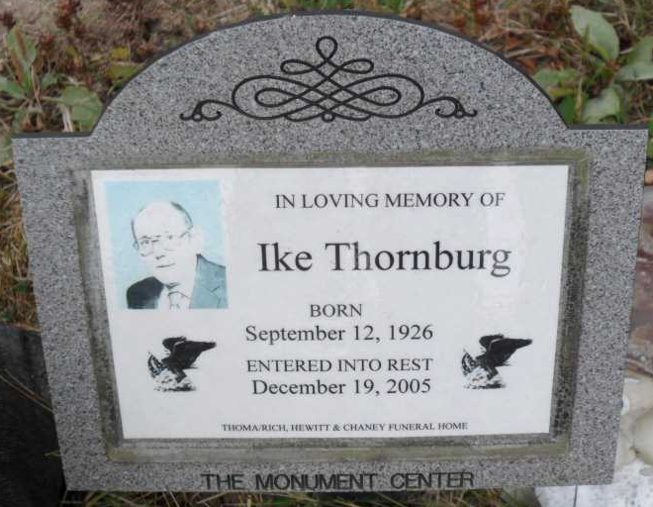
Photo by Pretty Little Grave Seekers

Ike Thornburg, 79, of Bluffton died at 10:15 a.m. Monday, Dec. 19, 2005, at his residence. Mr. Thornburg had worked for Peter Eckrich, retiring in 1986 after 34 1/2 years of service. He attended Chester Center Schools and served in the U.S. Army.
Mr. Thornburg was born Sept. 12, 1926, in Gaston to Vasco D. and Emma (Bales) Thornburg. His marriage on Aug. 24, 1968, in Wells County was to Judy Romine, who survives.
Other survivors include a daughter, Mrs. Dave (Pam) Caldwell of Bluffton, two sisters, Mildred Towne of Desert Palms, Calif., and Elsie Daugherty of Andrews; a brother, Herbert A. Thornburg of Haddix, Ky.; six grandchildren; and nine great-grandchildren.
He was preceded in death by a sister, Rosemary Teeple; a brother, Arthur E. Thornburg; and two grandchildren, Joey Caldwell and Christy Tanksley.
Services are at 2 p.m. Thursday at Thoma/Rich, Hewitt & Chaney Funeral Home with Pastor Tom Bradley officiating. Calling is from 2 to 8 p.m. Wednesday and one hour prior to services Thursday at the funeral home. Burial will be in Fairview Cemetery.
Preferred memorials are to Family Hospice of Northeast Indiana.

Bluffton News-Banner, Wells County, Indiana
Tuesday, Dec. 20, 2005

