Janet Louise Thompson
January 6, 1940 – January 21, 1940

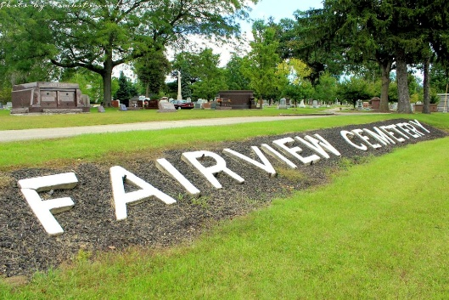
Photo by Tombstoner & Family

THOMPSON

Bluffton, Jan. 21 – Janet Louise Thompson, aged 15 days, daughter of Mr. and Mrs. Donald Thompson, died here at 7 am today of bronchitis.
The parents, two brothers and a sister survive.
Funeral services will be held at 1:30 pm Monday at the Jahn Funeral Home, in charge of Rev. Evert Baker, and burial will be in Fairview Cemetery.

Fort Wayne Journal-Gazette, Wells County, Indiana
January 22, 1940
**

Janet Louise Thompson from tree Nick Butterworth Family Tree
Birth 6 Jan 1940
Death 21 Jan 1940
Father Donald Roosevelt Thompson (1908-1975)
Mother Wanetta Mae Gallimore (1917-1990)
11214 People 0 Records 1 Source

