Rex Eugene Terhune
January 31, 1926 – January 23, 1989

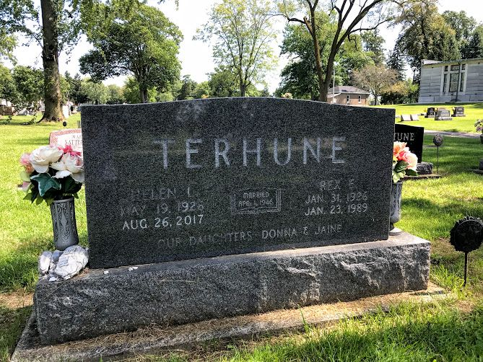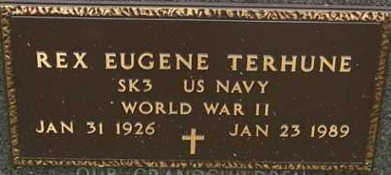
Photo by SMMR

Indiana, U.S., Death Certificates, 1899-2017
Name Rex Eugene Terhune
Gender Male
Race White
Marital Status Married
Age 62
Birth Date 31 Jan 1926
Birth Place Wells County, Indiana
Death Date 23 Jan 1989
Death Place Bluffton, Wells, Indiana, USA
Death Registration Date 1989
Father Daniel Terhune
Mother Edith Frantz
Spouse Helen Satterfield Terhune, informant
Burial 1/25/1989 Fairview

