Helen L. (Satterfield) Terhune
May 19, 1926 – August 26, 2017

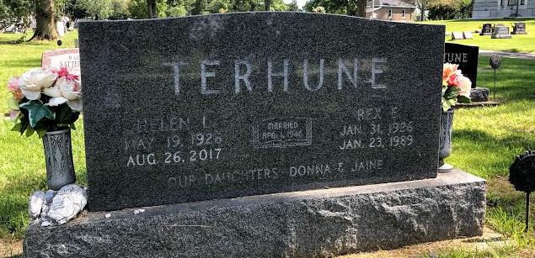Photo by SMMR

Helen L. Terhune, 91, of Bluffton passed away at her residence early on Saturday, August 26, 2017, in Bluffton.
She was born on May 19, 1926 in Gilbertsville, Kentucky to Herman Edward & Mary Ann (Culp) Satterfield. She attended Liberty Center High School and worked at Franklin Electric and at the Caylor-Nickel Clinic. Helen enjoyed spending time in her flower gardens, sewing and cooking for her family. On April 1, 1946 in Bluffton, Helen and Rex E. Terhune were married; he precedes her in death on January 23, 1989.
Survivors include two daughters Donna (Joseph) Hollopeter and Jaine Murray, both of Bluffton along with 9 grandchildren: David (Becky) Hollopeter, Tim Hollopeter, Lisa (Josh) Scott, Lori Murray, Ryan Murray, Kristen (Travis) McCune, Shannon Murray, Alex Murray and Kyle Murray and a great-grandson Cameron Quakenbush.
Helen is also survived by 2 sisters; Betty Arnold & Sue Taylor, both of Bluffton and a brother Herman Statterfield, also of Bluffton.
She is preceded in death by siblings; Hazel Reed, George, Tom & Billy Satterfield and a granddaughter Sarah Hollopeter.
A service to celebrate Helen’s life will be held at 10:30 A.M. on Wednesday (August 30, 2017) at the Thoma/Rich, Lemler Funeral Home in Bluffton. Burial will follow at Fairview Cemetery in Bluffton. Calling hours will be from 2 to 8 P.M. on Tuesday at the funeral home. Memorials may be made in Helen’s name to the charity of the donor’s choice.
Thoma/Rich, Lemler Funeral Home, Wells County, Indiana
August 27, 2017

