Mary Jane Taylor
August 12, 1935 – February 7, 2017

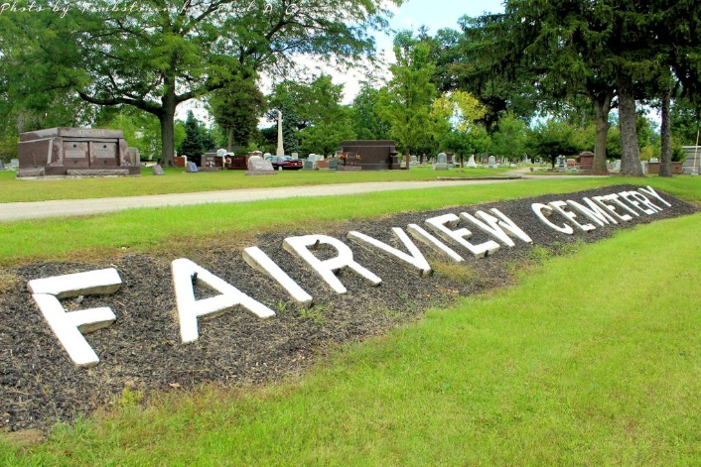
Photo by Tombstoner & Family

Mary Jane Taylor, 81, of Bluffton passed away at 2:07 p.m. Tuesday, February 07, 2017, at Vibra Hospital in Fort Wayne. Mary Jane was born on August 12, 1935 in Chester Township, Wells County to Lester C. & Mabel V. (Sheets) Taylor, and was raised by her step-father Floyd Spade.
She graduated from Bluffton High School with the class of 1953. She retired from the Kmart Corporation where she worked for over 35 years. She was a member of the First Reformed Church where she served for many years as the Sunday School Secretary and was on the board of Christian Education.
Survivors include by a sister-in-law Jo Spade of Warren, along with nieces & nephews: Kathy (Dave) Golden of Zanesville, Steve (Linda) Sturgeon and Jim (Carol) Sturgeon, both of Bluffton, Beth (Bryan) Zukowski of Glenwood Springs, CO., Meg (Kent) Ulery of Arlington Heights, IL., David (Sandy) Spade of McCordsville, IN., Connie (Craig) Mounsey of Huntington, IN. and Jackie (Dan) Norris of Markle, In.
She is preceded in death by a brother William M. Spade and two sisters Patricia Ann Turner and Jean L. Sturgeon.
A service to celebrate Mary Jane’s life will be held at 10:30 a.m. on Monday (February 13, 2017) at the Thoma/Rich, Lemler Funeral Home in Bluffton. Burial will follow at Fairview Cemetery in Bluffton. Celebrant Jeff Lemler will officiate. Calling hours will be held from 1 p.m. to 6 p.m. on Sunday at the funeral home, and for one hour prior to the service on Monday. Memorials may be made to First Reformed Church or Friends of the Wells County Animal Shelter.
Thoma/Rich, Lemler Funeral Home, Wells County, Indiana
February 8, 2017

