Kathryn Justine (Kelly) Tangeman
February 14, 1908 – August 19, 2002

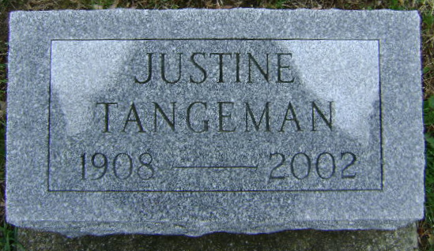
Photo by Bruce Sonner

Indiana, U.S., Marriages, 1810-2001
Name Kathryn Justine Kelly
Gender Female
Event Type Marriage Registration (Marriage)
Marriage Date 9 Nov 1930
Marriage Place Indiana, United States
Spouse Fred Osborne Tangeman
**
U.S., Social Security Death Index, 1935-2014
Name Kathryn J. Tangeman
Social Security Number xxx
Birth Date 14 Feb 1908
Issue year Before 1951
Issue State Indiana
Last Residence 49546, Grand Rapids, Kent, Michigan, USA
Death Date 19 Aug 2002
**
Katherine Justine Kelly from tree Cindy Conover Family Tree
Birth 20 Feb 1908 Wells, Indiana, USA
Marriage 9 Nov 1930 Indiana, USA
Residence 1 Apr 1940 Bluffton, Wells, Indiana, USA
Death 19 Aug 2002 Grand Rapids, Kent, Michigan, USA
Father Arthur Philbert Kelly (1872-1934)
Mother Anna Margaret Dougherty (1876-1965)
Spouse Frederick Osborn Tangeman (1906-1980)
39992 People 12 Records 24 Sources

