Frederick Osborne Tangeman
October 29, 1906 – November 10, 1980

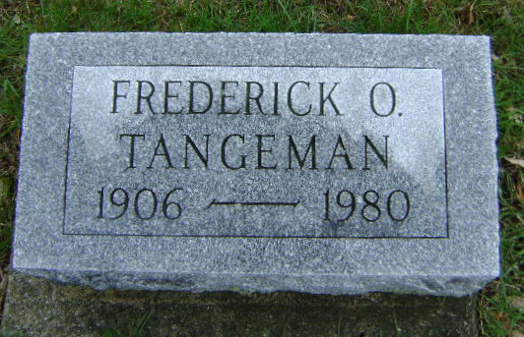
Photo by Bruce Sonner

BLUFFTON – Fred O. Tangeman, 74, died at 1:40 pm Monday in the Caylor-Nickel Hospital.
Surviving are his wife, Justine; two daughters and a son.
Services are at 10:30 am Thursday in the Thoma-Rich Funeral Home. Calling there after 1 pm Wednesday.

Journal-Gazette, Allen County, Indiana
November 11, 1980, Page 10C
**

Indiana, U.S., Death Certificates, 1899-2017
Name Frederick O. Tangeman
Gender Male
Race White
Marital Status Married
Age 74
Birth Date 29 Oct 1906
Birth Place Indiana
Death Date 10 Nov 1980
Death Place Bluffton, Wells, Indiana, USA
Death Registration Date 1980
Father Frederick J. Tangeman
Mother Janie Osborne
Spouse Justine Kelly Tangeman, informant
Burial Fairview Cemetery 11/13/1980

