Sherry L. (Stirling) Symon
April 14, 1951 – September 6, 2010

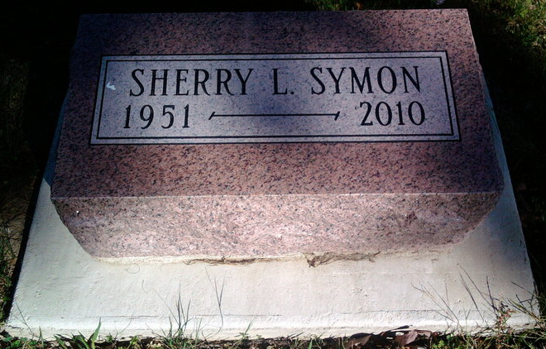
Photo by Thomas Liby

Sherry L. Symon 59, of Bluffton, IN, passed away Monday, Sept. 6, 2010. She was born in Indianapolis on April 14, 1951, to John C. Sr. and Evelyn (Essig) Stirling. She married John E. Symon on May 27, 1984; he survives. A 1969 graduate of Manual High School she was a member of St. Mark's Presbyterian Church in Indy. Also surviving is a brother, John C. (Wilma) Stirling Jr. of Greenwood, IN. A funeral service will be held Friday, at 2:00 p.m., at Goodwin Memorial Chapel in Bluffton, IN, with calling hours from 11:00 a.m. to 2 p.m., prior to the service. Burial will be at Fairview Cemetery in Bluffton.

The Indianapolis Star, Marion County, Indiana
Sep. 8, 2010
**

Sherry L. Symon, 59, of Bluffton, IN, passed away at her residence at 11:50 p.m., Monday, Sept. 6, 2010, after a thirteen month battle with A.L.S., (Lou Gehrig's Disease). Mrs. Symon was born in Indianapolis on April 14, 1951, to John C. Stirling Sr. and Evelyn (Essig) Stirling. She married John E. Symon in Las Vegas, at the Chapel of the Bells, on May 27, 1984; he survives.
A 1969 graduate of Manual High School, Mrs. Symon worked at Rural King in Decatur, IN for two years. She also was a member of St. Mark's Presbyterian Church in Indianapolis.
Other surviving relatives include one brother, John C. (Wilma) Stirling Jr. of Greenwood, IN; and also her Basset Hound, Lucy Mae.
Calling hours will be from 11:00 a.m. to 2 p.m., Friday, September 10, at Goodwin Memorial Chapel in Bluffton. Funeral Services will be held at 2:00 p.m. Friday, at the funeral home with Rev. Robert Madsen officiating. Burial is at Fairview Cemetery in Bluffton.
Preferred Memorials are to Family Hospice & Palliative Care or the A.L.S. Association, Indiana Chapter.

Unknown source

