James Caylor Symon
September 1, 1957 – January 21, 1959

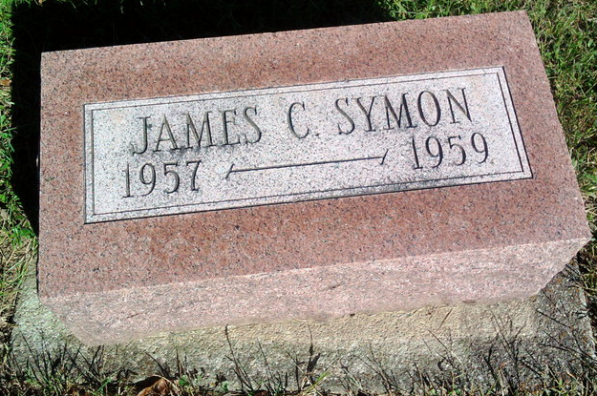
Photo by Thomas Liby

INFANT SON OF DR. AND MRS. WILLIAM SYMON DIES
James Caylor Symon, 16-month-old son of Dr. William E. and Patricia Caylor Symon of 632 South Main St., died at 4:30 a.m. today at his home. He had been ill since birth. He was born Sept. 1, 1957, at the Clinic Hospital.
Surviving in addition to the parents, are a sister, Anne Symon, and two brothers, William and John Symon, all at home.
Graveside services will be conducted at 10 a.m. Thursday at the Fairview Cemetery. Rev. Keith Davis will officiate. Thoma Funeral Home is in charge of the services.

Bluffton News-Banner, Wells County, Indiana
Wednesday, January 21, 1959, Page 1, Column 7

