Kathleen L. (James) Swinford
July 15, 1928 – August 17, 2022

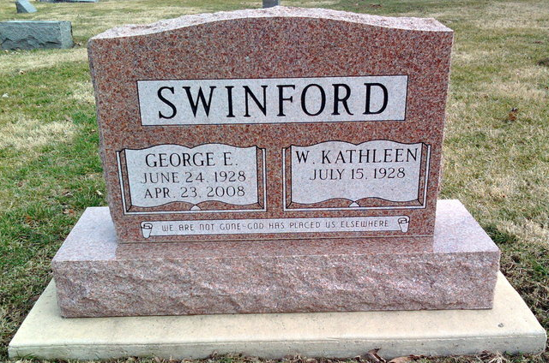
Photo by Thomas Liby

Kathleen Swinford, 94 of Bluffton, passed away on Saturday afternoon, August 27, 2022, at River Terrace in Bluffton. Born on July 15, 1928, in North Judson, Indiana to Adam & Velma (Bane) James. She graduated from North Judson High School with the class of 1946 and graduated from Franklin Beauty College in Logansport. A Bluffton resident since 1969, Kathleen worked alongside her husband and served as the bookkeeper of Briner Building, Inc. from 1969 to 1983, and Bluffton U-Store from 1984 – 2020.
In her retirements, she volunteered at the Bargain Hut, and was a member of the Wells County Master Gardeners Club. She enjoyed working in her flower gardens, watching birds and reading. Kathleen was a long-time member of the First United Methodist Church.
On June 2, 1950, in Frankfort, Kathleen and George Swinford were married. They shared 58 years of marriage before he preceded her in death on April 23, 2008.
Survivors include a son, Mike (Debbie) Swinford of Fort Wayne, four grandchildren; Krista Swinford and Nick Swinford, Jennifer (Ty) Miller, and Sarah (Frank) Johnson, along with 8 great-grandchildren; Hunter Battell, Triston, Ellie, and Hattie Miller, and Devin, Corian, Dillan, and Emma Jane Johnson, with her 9th grandson arriving soon.
She is also survived by a sister, Carol Brownsburger of Elkhart, IN; and a brother-in-law; Bob (Shirley) Swinford of Lafayette, IN,
She is preceded in death by her parents, husband and a son, Ronald Swinford, a brother, Bob James and sister, Muriel Baker.
Funeral services will be at 11 A.M. on Thursday (September 1, 2022) at the Thoma/Rich, Lemler Funeral Home in Bluffton with Pastor Sherrie Drake officiating. Directly following the funeral service, there will be a luncheon and reception in the fellowship hall of the First United Methodist Church, directly across the street of the funeral. All are welcome to join the family for a graveside committal service at 2:30 P.M. on Thursday, at Fairview Cemetery, following the reception.
Calling Hours will be held from 5 P.M. to 8 P.M. on Wednesday at the funeral home and for one hour prior to the service on Thursday.
Memorials may be made in Kathleen's memory to the First United Methodist Church, Eleos Hospice Care or River Terrace Estates.

Thoma/Rich, Lemler Funeral Home, Wells County, Indiana

