George E. Swinford
June 24, 1928 – April 23, 2008

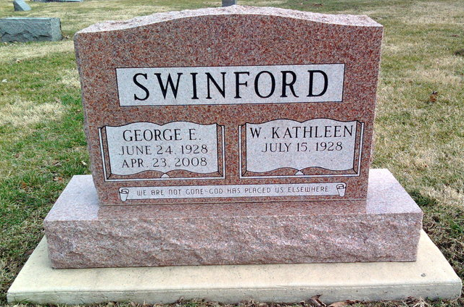
Photo by Thomas Liby

George Swinford, 79, of Bluffton, died at 9 p.m. Wednesday, April 23, 2008, at Meadowvale Health and Rehabilitation Center. Born in Thorntown on June 24, 1928 to Floyd and Lottie (Batts) Swinford, he married Kathleen James in Frankfort on June 2, 1950; she survives.
A 1946 graduate of Frankfort High School, Mr. Swinford also graduated from Purdue University in 1950. He worked at the Conner Prairie Farms, Chester Hybrids and Orville Reidenbacher, before purchasing Briner Building in 1969, which he owned until 1983. He subsequently owned and developed Harrison Shopping Center and the Bluffton U-Stor.
He served in the Army Reserve ROTC as Captain and was an active member. He was also a member of the Moose Lodge, Elks Lodge, Bluffton Masonic Lodge #145 and the Mizpah Shrine.
Other surviving relatives include two sons, Michael (Deborah) Swinford of Fort Wayne and Ronald Swinford of Bluffton; one brother, Bob Swinford of Lafayette; four grandchildren and five great-grandchildren.
Mr. Swinford was also preceded in death by three brothers, Marvin, Jim and Laverne Swinford.
Funeral services will be at 10 a.m. Saturday, at the Thoma/Rich, Chaney & Lemler Funeral Home in Bluffton, with Pastor Cindy Osgood officiating. Calling hours will be from 4 to 8 p.m. Friday at the funeral home. Burial is at Fairview Cemetery, in Bluffton. Preferred memorials are to the American Diabetes Association.

Bluffton News-Banner, Wells County, Indiana
Thursday, April 24, 2008

