Willet Cary Sweeny
December 28, 1862 – May 11, 1942

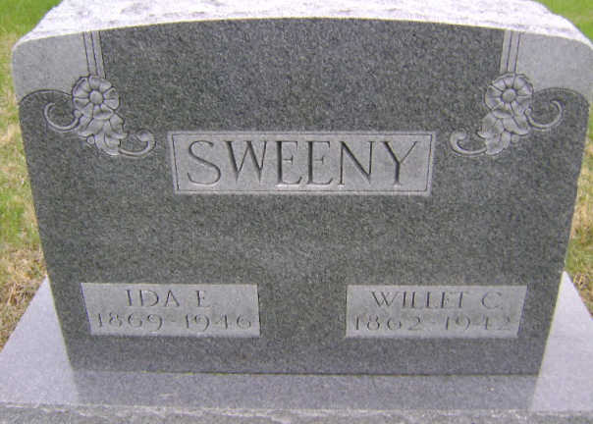
Photo by Bruce Sonner

WILLET C. SWEENY ANSWERS SUMMONS
DEATH OCCURS THIS MORNING AT HOSPITAL HERE
FUNERAL TO BE WEDNESDAY
Willet C. (Will) Sweeny, 79, died at 6:35 a. m. today at the Wells county hospital, following an illness of four weeks of complications, due to a fall. He was taken to the hospital Friday morning from his home, southeast of Bluffton.
The decedent was born Dec. 28, 1862 in Wayne county, O., a son of John Wesley and Jemima Cary Sweeny. He came to Wells county in 1879 and had resided here since. His marriage Dec. 22, 1892, at Tocsin was to Ida Sowards, who survives. He was an active member of the Wesleyan Methodist Church.
Surviving besides the widow are two sons, Robert J. Sweeny, route 3, and Alfred Sweeny, of Mishawaka; three daughters, Mrs. May DeRuyscher, and Miss Ether Sweeny, both at home, and Mrs. Garth Double, Uniondale, route 1; nine grandchildren; and four sisters, Mrs. John Nixon, of Fredericksburg, O., Mrs. Francis Thurber, of Bluffton, Mrs. Henry Arnold of Battle Creek, Mich., and Mrs. Frank Poffenberger, of Montgomery, Mich., and a brother, Robert E. Sweeny died last July.
The body will be taken from the Jahn funeral home this evening to the residence.
Funeral services will be held at 2 p. m. Wednesday at the Nazarene church in charge of Rev. V. S. Vardaman, assisted by Rev. Jacob Schell. Burial will be in the Fairview cemetery.

Bluffton News-Banner, Wells County, Indiana
Monday, May 11, 1942, Page 1, Column 6

