Ida Ellen (Sowards) Sweeny
October 2, 1869 – July 20, 1946

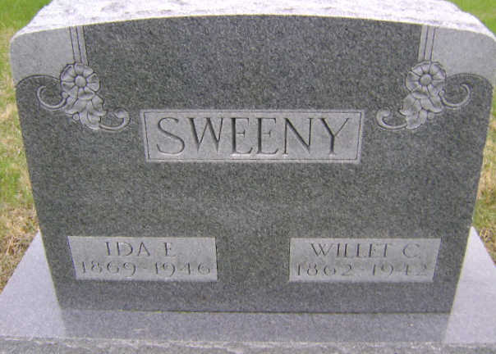
Photo by Bruce Sonner

MRS. IDA SWEENY IS DEAD AFTER STROKE
Mrs. Ida Ellen Sweeny, 76, died at 2:15 a. m. today at her home three and one half miles south and east of Bluffton following an illness of six and one-half months. Death was due to a stroke of paralysis.
Born Oct. 2, 1869, in Wells county, Mrs. Sweeny was a daughter of T. J. and Rachel Dailey Sowards. She was married at Tocsin Dec. 22, 1892 to Willit C. Sweeny, whose death occurred May 11, 1942.
Surviving are two sons, Robert Sweeny, route 3, and Alfred Sweeny, of Mishawaka; three daughters, Mrs. May Deruyscher, route 3, Mrs. Garth Double of Uniondale, and Miss Esther Sweeny, at home; two grandchildren reared in the home; seven other grandchildren; a sister, Mrs. Herman Lindeman, of Fort Wayne, and a brother, John R. Sowards, of Bluffton. Two sisters, Mrs. John Nash and Mrs. Reuben Nash are deceased.
The body was taken to the Jahn funeral home where friends may call after 5 o'clock this afternoon. The body will be taken to the residence Sunday morning.
Funeral services will be held at 2 p. m. Monday at the Wesleyan Methodist church, of which Mrs. Sweeny was a member, in charge of Rev. Glenn Appleman. Burial will be in the Fairview cemetery.

Bluffton News-Banner, Wells County, Indiana
Saturday, July 20, 1946, p. 1, c. 3

