Doyle W. Sullivan
June 12, 1926 – August 1, 2014

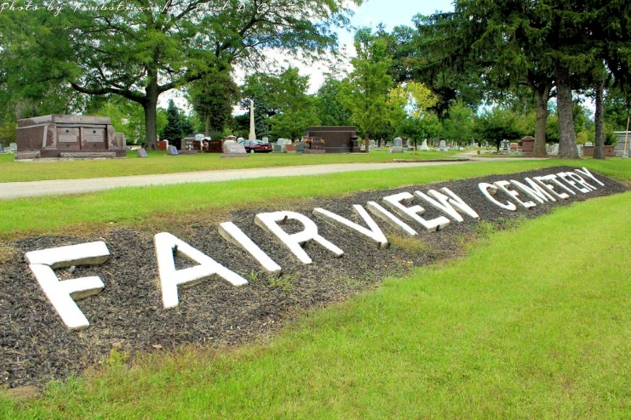
Photo by Tombstoner & Family

Doyle W. Sullivan, 88 of Bluffton passed away at 9:40 p.m. Friday, August 1, 2014 at Bluffton Regional Medical Center.
Mr. Sullivan was born on June 12, 1926 in Uniondale, Indiana to Orville & Loretta (Crismore) Sullivan. He graduated from Liberty Center High School. He served our country in the United State Army from 1944 to 1947 as a heavy machine gunner during World War II. He worked as a supervisor for Franklin Electric for many years, retiring in 1986. He went with Franklin as a plant manager and set up the plant in Siloam Springs, Arkansas. He also worked for some time at Lakes Engineering Company. He was a member of the American Legion Post #111 of Bluffton and really enjoyed spending time with his grandchildren.
On October 7, 1950 at the Poneto United Methodist Church, Doyle and Bonnie V. (Bennett) were married. They have shared almost 64 years together. Bonnie survives in Bluffton along with a son Terry Sullivan of Decatur and a daughter Athena (husband John) Detrick of Hayward, WI. along with two grandchildren and four great-grandchildren along with a sister Barbara (husband Curtis) Prough of Bluffton.
He is preceded in death by a son Jeffery Alan Sullivan along with two brothers; Paul Falk and Orville ‘JR.’ Sullivan.
A service to celebrate Doyle’s life will be held at 1:00 p.m. on Wednesday, August 6, 2014, at the Thoma/Rich, Lemler Funeral Home. Pastor John Cole will officiate. Calling hours will be held from 2 to 8 on Tuesday at the funeral home. Burial will take place at Fairview Cemetery in Bluffton, where military honors will be performed by the United States Army Honor Guard and the American Legion Post #111 Honor Guard. Memorials may be given to the charity of the donor’s choice through the funeral home.
Thoma/Rich, Lemler Funeral Home, Wells County, Indiana

