Bonnie V. (Bennett) Sullivan
July 22, 1928 – January 1, 2018

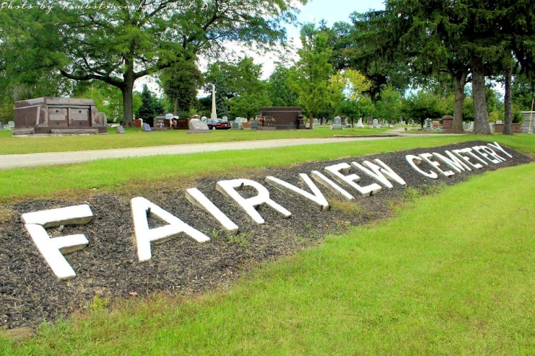
Photo by Tombstoner & Family

Bonnie V. Sullivan, 89, of Bluffton passed away on Monday evening, January 1, 2018, at Chalet Village in Berne.
She was born in Chester Township on July 22, 1928 to Edson & Clara (Goodin) Bennett. Bonnie graduated from Chester Center School in 1946 and worked at Bachman Foods in Bluffton and also at the Bluffton News-Banner. She was a member of Park United Brethren Church
On October 7, 1950 at the Poneto United Methodist Church, Bonnie & Doyle W. Sullivan were married. They shared almost 64 years together and Doyle precedes her in death on August 1, 2014.
She is survived by a son Terry Sullivan of Decatur and her daughter Athena Dedrick of Warren along with two grandchildren Christopher Hanson of Bluffton, Joshua Hanson of Decatur and great-grandchild-ren: Katie Hanson of Bluffton, Justin Hanson of Bluffton, Brock Hanson of Ossian and Abby Hanson of Lafayette and one great-great-granddaughter Phoebe Berkey of Bluffton and her caregiver Dora Kahn along with many nieces and nephews. Bonnie is also survived by 4 sister-in-laws: Carolyn Bennett of Bluffton, Catherine Bennett of Portland, Barbara Prough of Bluffton and Shirley Sullivan of Fort Wayne.
She is preceded in death by a son Jeffery Alan Sullivan in 1960 along with siblings: Cleo Aker, Ruby Gentis, Ralph Bennett, Claude Bennett and Robert “Bob” Bennett.
A service to celebrate Bonnie’s life will be held at 10 A.M. on Friday (January 5, 2018) at the Thoma/Rich, Lemler Funeral Home in Bluffton. Pastor John Cole will officiate. Burial will follow at Fairview Cemetery in Bluffton. Calling hours will be held from 2 to 4 & 5 to 7 on Thursday at the funeral home. Memorials may be made to your local animal shelter of the donor’s choice.
Thoma/Rich, Lemler Funeral Home, Wells County, Indiana
January 2, 2018

