Alden Koch Studebaker
July 31, 1892 – November 7, 1955

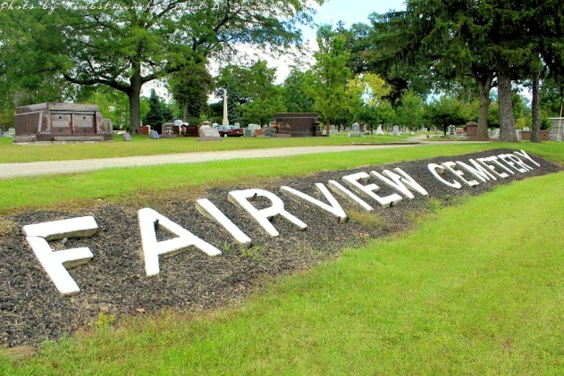
Photo by Tombstoner & Family

KILLS SELF IN CAR
CHESTERTON, Ind. (UP)—The body of 'Alden. K. Studebaker, 65, Dane Acres, was found in a parked car Monday near his home. The motor was running and a hose led from the exhaust through a rear window into the car's interior.

Logansport Pharos-Tribune, Cass County, Indiana
November 8, 1955, p. 5
**
Dune Acres Man's Body Found In Car
DUNE ACRES, Nov. 8 – A retired Dune Acre Contractor who built may of the original homes in this fashionable north Porter county Community on the shores of Lake Michigan, committed suicide late Monday afternoon State police and the coroner's office reported today. Carbon Monoxide victim was Alden K. Studebaker, 63, Dune Acres, who had been despondent over ill health, authorities were advised. His body was found in his car in a wooded area about 200 feet of the road leading to the west end of Dune Acres by Eckland of Dune Acres, who was checking duck blinds in the vicinity. Headlights of Eckland's auto revealed Studebaker's car parked in the woods. Motor was still running, according to police, who said they found a flexible tube running from the car's exhaust to the rear window of the auto. Other windows were closed.
Dead About 30 Minutes
The victim apparently died about 5 p. m., Monday, about 30 minutes before Eckland spotted the car, police said. Studebaker was one of the leading figures in the development of this community 30 years ago and known as the best builder of log houses in the area He also built many of the exclusive conventional homes in the town and many of the principal roads. He lived here 31 years and also resided in Texas, from where he returned to Dune Acres last spring.
A World War I veteran he served 19 months in France. He was a member of F&AM Chapter 95, Bluffton, Ind., and a member of the Bluffton Commandary 145 Knights Templar. Born in Bluffton July 31, 1892, he was the son of Hugh D. and Mary Koch Studebaker. He married Naomi V. Chellberg at the Augsburg Lutheran church, Porter, on June 24, 1926.
Surviving are his widow; and two sons, Alden H., and Arthur L., both at home.
Services will be held at 7:30 p. m., Wednesday in Flynn-Johnson Funeral home. The Rev. Carl I. Fant will officiate. Body will then be taken to the William H. Thoma and Son Funeral home Bluffton, where services will be held at 1:30 p. m., Friday Burial will be in Bluffton cemetery. Friends may call at the Johnson Funeral home from this evening until services there Wednesday.

Vidette Messenger, Porter County, Indiana
November 8, 1955, p. 1
**

Indiana, U.S., Death Certificates, 1899-2017
Name Alden Koch Studebaker
Gender Male
Race White
Marital Status Married
Military WW I
Age 63
Birth Date 31 Jul 1892
Birth Place Bluffton, Indiana
Death Date 7 Nov 1955
Death Place Rural, Porter, Indiana, USA
Cause of death Suicide, Carbon monoxide in car
Death Registration Date 1955
Father Hugh D Studebaker
Mother Mary Koch
Spouse Naomi Studebaker, informant
Burial 11/11/1955 Bluffton Cemetery

