Floyd Wesley Stucky
April 4, 1909 – April 28, 1940

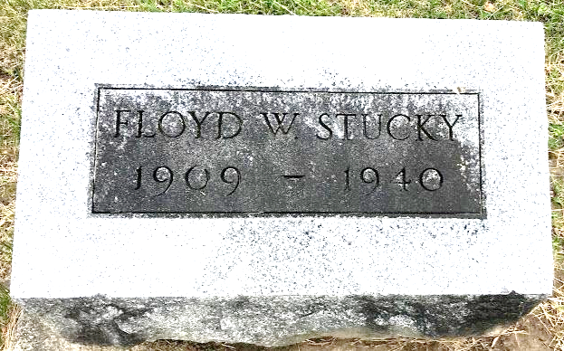
Photo by SMMR

STUCKY

Bluffton, April 29 - Floyd Stucky, 31, manager of a Morris Store at Dwight, Ill., died there yesterday after an illness of a month of complications, including influenza. He was a former resident of Vera Cruz, Wells County and had been manager of the Dwight Store eight years.
Surviving are the widow, formerly Catherine Gilbert of this city; the mother, Mrs. Lena Stucky of Vera Cruz; a son, Tommy; a sister, Mabel Stucky of Michigan and three brothers, Walter and Abraham Stucky of Pennsylvania and Wilmer Stucky of Domestic.
The body will be brought here for funeral services at 2 pm Wednes-day at the First Methodist Church and burial will be in Fairview Cemetery.

Journal-Gazette, Allen County, Indiana
April 30, 1940
**

Bluffton – Rites for Floyd Stucky, age thirty-one, former resident of Vera Cruz and manager of a 5 and 10-cent store at Dwight, Ill., were held today. The widow, a son and three sisters survive. The body was brought here for additional services and burial.

Indianapolis News, Marion County, Indiana
Wednesday, May 1, 1940
**

Illinois, U.S., Deaths and Stillbirths Index, 1916-1947

Name Floyd Wesley Stucky
Birth Date 4 Apr 1909
Birth Place Adams County, Indiana
Death Date 28 Apr 1940
Death Place Dwight, Livingston, Illinois
Burial Date 1 May 1940
Burial Place Adams Township, Indiana
Cemetery Name Fairview
Death Age 31
Occupation Store Manager-M&M Syndica
Race White
Marital Status M
Gender Male
Residence Dwight, Dwight, Livingston, Illinois
Father Name Amos Stucky
Mother Name Lena Dubach
Mother Birth Place Switzerland
Spouse Name Kathryn G.
FHL Film Number 1831995

