Sarah F. (Nicely) Stover
February 9, 1869 – December 17, 1942

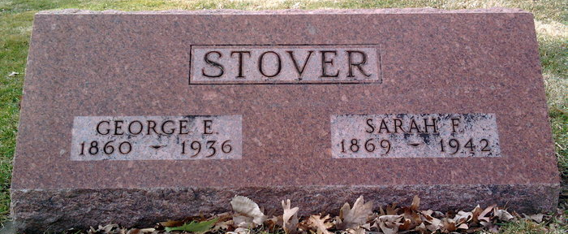
Photo by Thomas Liby

Indiana, U.S., Death Certificates, 1899-2017
Name Sarah F Stoner (indexed as Storer)
[Sarah F Nicely]
Gender Female
Race White
Marital Status Widowed
Age 73y 10m 8d
Birth Date 9 Feb 1869
Birth Place Wells County, Indiana
Death Date 17 Dec 1942
Death Place Bluffton, Wells, Indiana, USA
Death Registration Date 1942
Father John Nicely
Mother Rabecca Garby
Spouse George Storer
Informant Lloyd Stoner
Burial 12-19-1942 Fairview

