George Estell Stover
March 16, 1860 – August 10, 1935

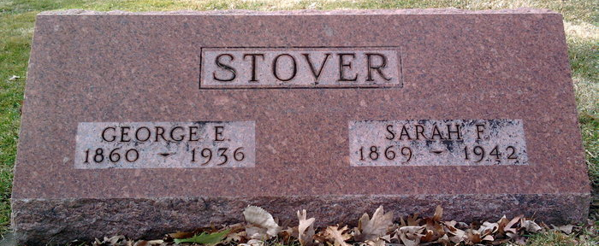
Photo by Thomas Liby

GEORGE E. STOVER CALLED BY DEATH.
WELL KNOWN RETIRED GROCER PASSES AWAY MONDAY NIGHT

George E. Stover, 76, retired Bluffton grocer, died Monday evening at his home, 918 South Main Street, following a stroke of paralysis Saturday. Mr. Stover was born in Wells county on March 16, 1860 a son of George and Elizabeth Wertz Stover, and lived his entire life in the county. He was a grocer for 40 years.
His first marriage was to Martha Machan, who preceded him in death. He then married Nancy Griffin, who also is deceased. His third marriage to Sarah F. Nicely, was solemnized on Oct 23, 1894 at Muncie.
Surviving are the widow; two sons, Lloyd of Bluffton, and Harry A. Stover, of Rockville; three grandchildren; and one half-brother, Charles Boden, of Francisville. Two half-sisters and one half-brother are deceased.
He was a member of the Presbyterian church.
Funeral services will be held at 3 o'clock Wednesday afternoon at the home, in charge of Rev. W.M. Elliott. Burial will be in Fairview cemetery. Friends are requested to omit flowers.

Bluffton Evening News, Wells County, Indiana
11 Aug 1936

