Norman E. Sprunger
May 27, 1911 – July 13, 1980

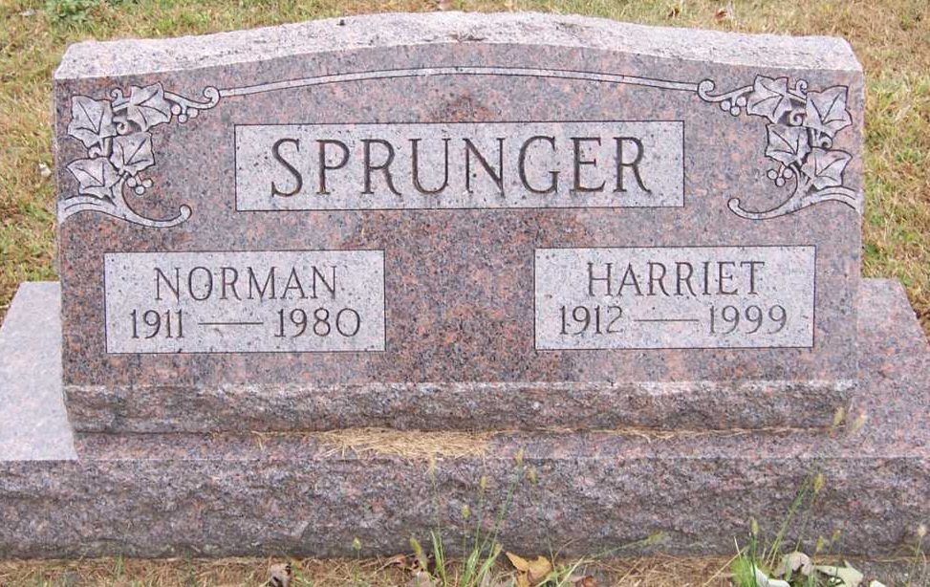
Photo by Pretty Little Grave Seekers

Indiana, U.S., WPA Birth Index, 1880-1920

Name Norman Sprunger
Gender Male
Birth Date 27 May 1911
Birth Place Adams, Indiana, USA
Father Emil A Sprunger
Mother Matilda Hirschy
Book H-13
Page 12
**
U.S., Social Security Death Index, 1935-2014
Name Norman Sprunger
Social Security Number xxx
Birth Date 29 May 1911
Issue year Before 1951
Issue State Indiana
Last Residence 46804, Fort Wayne, Allen, Indiana, USA
Death Date Jul 1980
**

Norman E Sprunger from tree Hirschy Family Tree
Birth 29 May 1911 Indiana, USA
Residence 1 Apr 1940 Wells, Indiana, USA
Death 13 Jul 1980 Fort Wayne, Allen, Indiana, USA
Father Emil Alfred Sprunger (1881-1944)
Mother Marinda E Sprunger (1883-1969)
Spouse Harriet Marguerite Sprunger (Born 1914)
11262 People 6 Records 6 Sources

