Marilyn Jane Sprunger
October 1, 1939 – June 9, 1941

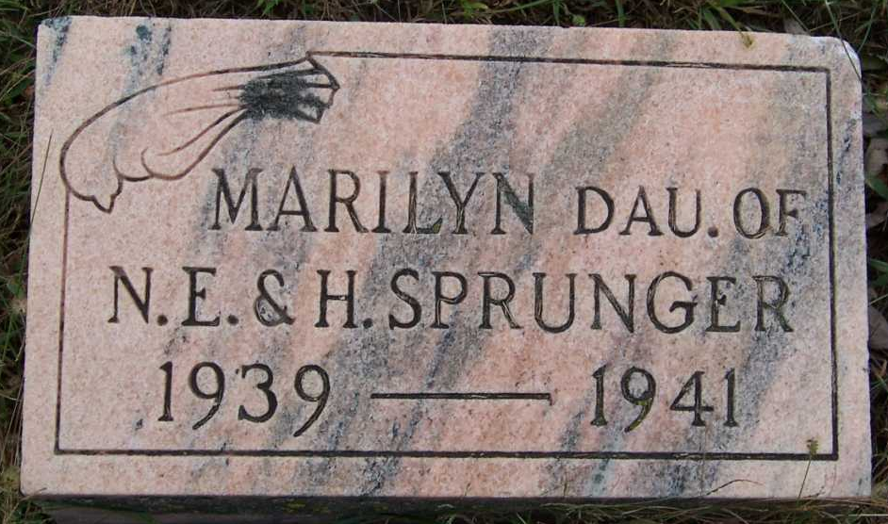
Photo by Pretty Little Grave Seekers

Norman Sprunger Child Succumbs

Marilyn Jane Sprunger, age one, daughter of Mr. and Mrs. Norman Sprunger, died at 4 p.m. Monday at the home of the parents, a mile north of Bluffton. She had been seriously ill the past three weeks from complications.
She was born in Wells county on Oct. 1, 1939, a daughter of Norman and Harriett Luginbill Sprunger. Surviving besides the parents are the grandparents, Mrs. and Mrs. Emil Sprunger, of Berne, and Mr. and Mrs. Joe Luginbill, north of Bluffton.
Funeral services were held at 2 p.m.(CST) today at the Joe Luginbill home in charge of Rev. C. J. Gerig, of Berne. Burial was in Fairview cemetery.

Adams County (IN) Historical Museum
1941a Jan-June Scrapbook, image 115
Handwritten-Wed. June 11, 1941

