Harriet Jane (Luginbill) Sprunger
August 15, 1912 – September 11, 1999

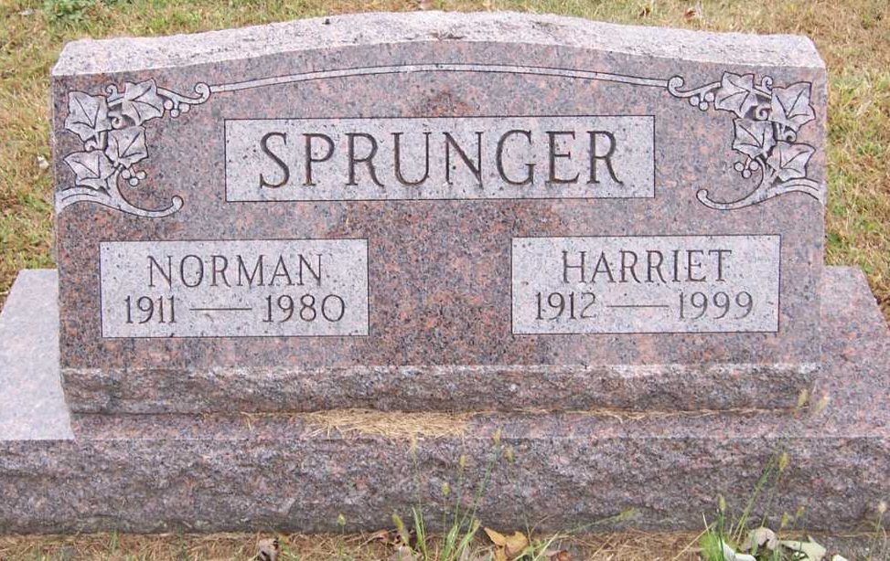
Photo by Pretty Little Grave Seekers

Harriet J Sprunger
in the Indiana, U.S., Death Certificates, 1899-2011
Name: Harriet J Sprunger
[Harriet J Luginbill]
Gender: Female
Race: Caucasian (White)
Age: 87
Marital status: Widowed
Birth Date: 15 Aug 1912
Birth Place: Berne, Indiana
Death Date: 11 Sep 1999
Death Place: Fort Wayne, Allen, Indiana, USA
Father: Joe Luginbill
Mother: Mary Girod
Informant: Stanley Sprunger; son; Roanoke, Indiana
Burial: September 14, 1999; Fairview Cemetery; Bluffton, Indiana

