Heath Thomas Springer
March 26, 2018 – March 26, 2018

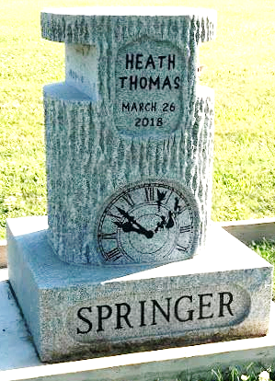
Photo by SMMR

Heath Thomas Springer was stillborn into the loving arms of his parents at 9:52 p.m. Monday, March 26, 2018, at Parkview Regional Medical Center in Fort Wayne. Heath is survived by his parents Eric R. and Ryan Kathleen (Powers) Springer, grandparents Jack and Debra Springer, uncle Zach (Meghann) Powers, and an aunt Kristen (Trent) Mounsey, all of Bluffton.
He was preceded in death by his grandma, Sheryl A. Peeper-Powers, and an uncle Evan Powers.
A graveside service will be held at 10:30 a.m. Tuesday, April 3, 2018, at Fairview Cemetery in Bluffton. Brent Arnold will officiate. Memorials may be made in Heath’s memory to Kate's Kart or Parkview Foundation - Women’s and Children’s Hospital.
Thoma/Rich, Lemler Funeral Home, Wells County, Indiana
March 30, 2018

