Peggy J. Spichiger
1931 - 2001

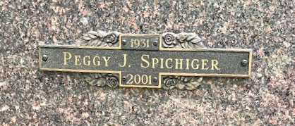
Photo by SMMR

No further information found at this time.

