Lloyd Edward Spichiger
November 16, 1930 – June 4, 2017

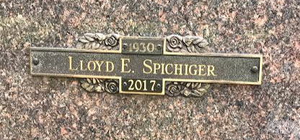
Photo by SMMR

Lloyd Edward Spichiger, age 86, passed away Sunday, June 4, 2017 at his home in Indianapolis. Lloyd was born November 16, 1930 at home in Linn Grove, IN to Edwin and Dora Spichiger. He was a graduate of Harford High School. He worked for Eley TV and Appliance in Bluffton for 30 years, Restco Restaurant Equipment in Fort Wayne, IN and as a custodian for the Bluffton-Harrison MSD, Columbian elementary school and for several years volunteered with the Adams-Wells Hospice.
Lloyd’s hobbies included golf, bowling, traveling, dancing, whistling, and playing cards, (especially euchre and bridge). Lloyd played the drums for years in a band with his brother Bob and loved both playing and listening to music. He was a skilled woodworker, artist and loved creating oil paintings. Lloyd was a member of the First Reformed Church in Bluffton.
Lloyd is survived by his wife Karen and his son Keith Spichiger; son-in-law, Ken Erickson; 4 grandchildren; 3 great grandchildren; 3 step-children and 3 step-grandchildren. He was preceded in death by his wife of 50 years, Peggy and Daughter, Darlene (Spichiger) Erickson.
Funeral services will be held at 10:30 A.M. on Thursday, June 8, 2017, at the Thoma/Rich, Lemler Funeral Home in Bluffton. Dr. Bryson “Gene” Bell will officiate. Entombment will follow at the Northridge Mausoleum located in Fairview Cemetery. Calling hours will be held from 2 P.M. to 8 P.M. on Wednesday at the funeral home. Memorials may be made to the First Reformed Church or Family LifeCare of Berne.
Thoma/Rich, Lemler Funeral Home, Wells County, Indiana
June 5, 2017

