Mabel Veora (Sheets) Spade
December 9, 1905 – March 25, 1994

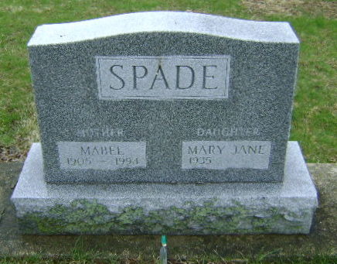
Photo by Bruce Sonner

Indiana, U.S., Death Certificates, 1899-2017
Name Mabel V Spade
Gender Female
Race White
Marital Status Widowed
Age 88
Birth Date 9 Dec 1905
Birth Place Wells County, Indiana
Death Date 25 Mar 1994
Death Place Bluffton, Wells, Indiana, USA
Death Registration Date 1994
Father Charles F Sheets
Mother Martha E Cole
Informant Mary Jane Taylor, daughter
Burial 3/28/1994 Fairview
**
Indiana, Marriages, 1810-2001
Name Mable Veora Sheets
Gender Female
Race White
Event Type Marriage Registration (Marriage)
Birth Place Wells, Indiana
Marriage Date 14 Jan 1935
Marriage Place Bluffton, Indiana, United States
Residence Place Liberty Center, Indiana
Father Charles F Sheets
Mother Martha Elizabeth Cole
Spouse Lester Charles Taylor
Page 191
FHL Film Number 002318978
**
Indiana, U.S., Marriage Certificates, 1960-2012
Name Mabel Veora Taylor
Gender Female
Race White
Marriage Age 32
Birth Date 9 Dec 1905
Birth Place Wells, Indiana
Marriage License Date 2 Jul 1938
Marriage Date 2 Jul 1938
Marriage Place Wells, Indiana, USA
Residence Place Liberty Center, Indiana
Spouse Floyd Raymond Spade

