Leah Clotene (Schwartz) Spade
May 24, 1904 – July 26, 1935

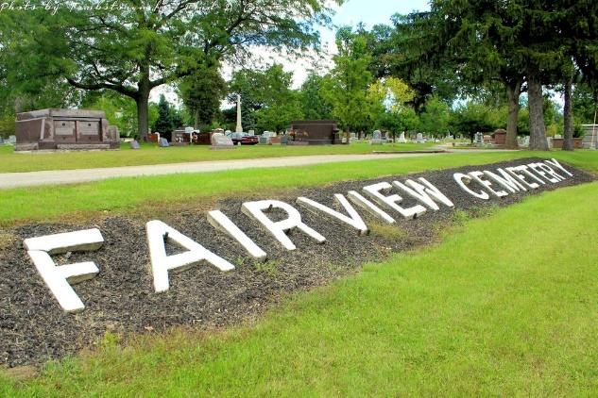
Photo by Tombstoner & Family

Indiana, U.S., Death Certificates, 1899-2017
Name Mrs Leah C Spade
Gender Female
Race White
Marital Status Married
Age 31y 3m 3d
Birth Date 24 May 1904
Birth Place Wells County, Indiana
Death Date 26 Jul 1935
Death Place Bluffton, Wells, Indiana, USA
Death Registration Date 1935
Father W H Schwartz
Mother Lota Watson
Spouse Floyd Spade, informant
Burial Fairview Mosleum 7-28-1935

