Amelia Jane (Blair) Snedden
June 17, 1857 – January 14, 1939

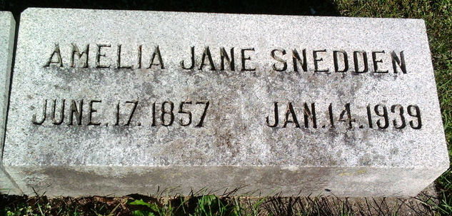
Photo by Thomas Liby

Permelia (sic) Jane Blair from tree Families of Western Pennsylvania
Birth 17 Jun 1857 Westmoreland, Pennsylvania, USA
Marriage 1873
Residence 1930 Fort Wayne, Allen, Indiana, USA
Death 14 Jan 1939 Fort Wayne, Allen, Indiana, USA
Father James G. Blair (1818-1873)
Mother Christina McDowell (1822-1894)
Spouse Alexander Ross Snedden (1852-1904)
2663 People 6 Records 6 Sources

