Alexander Ross Snedden
June 27, 1852 – January 28, 1904

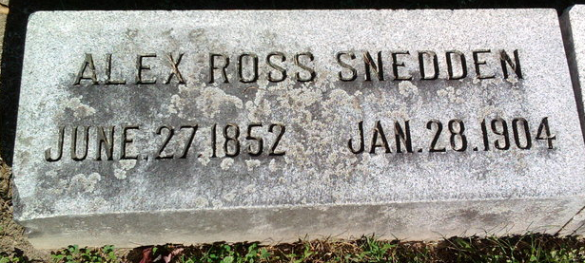
Photo by Thomas Liby

Alexander Snedden III

Word was received Thursday morning by Burgess McClain Crossland of New Haven of the serious illness of Alexander Snedden of Latrobe. Mr. Snedden has many friends and relatives in New Haven. He is a brother-in-law of A. H. Blair of New Haven. Mr. Crossland worked with Mr. Snedden at Latrobe for a number of years. He had been ailing for some time and two weeks ago he took a hemorrhage of the nose. The doctor cannot stop it successfully. He is in such a condition that his recovery is impossible. Mr. Snedden was engaged in the grocery business at Bluffton, Ind.

The Courier, Connellsville, Pennsylvania
January 29, 1904
**

Among those here Sunday to attend the funeral of A. R. Snedden were George Blair, of Williamsburg, Pa., Mrs. Elmer Welshouse, of Latrobe, Pa., brother and sister respectively of Mrs. Snedden, and Daniel Jones of Latrobe. The latter was Mr. Snedden's most intimate friend and the two were associated in business in the coal industry at Latrobe for many years previous to Mr. Snedden's moving to this city. Mrs. Welshouse is still here for a visit of some time with Mrs. Snedden but Messrs. Blair and Jones returned to Pennsylvania today.

Bluffton Chronicle, Wells County, Indiana
February 3, 1904
**

A. R. SNEDDEN DIED LAST THURSDAY NIGHT

Thursday eve, at a few minutes after 9 o'clock, after a brief, but ineffectual struggle for life, A. R. Snedden answered the call of the grim reaper and passed away. Mr. Snedden had been ill but a few weeks but in that time suffered immensely. His ailment was peculiar and is designated as a wasting of the red corpuscles of the blood. For a time he suffered from a severe bleeding at the nose and mouth but a short time before his death these hemorrhages were stopped.
During his last hours he was very restless and frequently asked that old familiar hymns be sung. This seemed to quiet him and afforded him great peace of mind. Frequently he feebly joined in the singing and evidenced a great deal of pleasure when such songs were rendered.
A. R. Snedden has been a resident of Bluffton for a number of years and during that time has been engaged in the grocery business. His first location was on West Market street in the building now occupied by G. E. Markley. Later he was in partnership with Henry Kershner and for some time has been conducting a store of his own on South Main street. During his residence in the city he has made many warm friends and always has a good word for everybody.
Mr. Snedden was born at McKeesport, Allegheny county, Pennsylvania, June 27, 1852. He was a son of Richard and Mary Snedden. His father died when he was yet a young man and his mother's death occurred in 1901. He has a brother, Richard Snedden, who resides at Coulter, Pa., and one sister, Mrs. Mary Duncan, who resides at Mt. Pleasant, Pa.
He was united in marriage to Miss Jennie Blair in 1873, and they have one child, Mrs. Will B. Gutelius, who resides in this city. Mr. Snedden was converted and united with the Methodist church twenty years ago at Latrobe. He was an official member of that church having been a member of the board of stewards for ten years.
While not an active [member] of the K. of P. lodge, he has been a member of that organization for the past thirty years, joining the order when 21 years of age at Latrobe. For 15 years during his residence at Latrobe, Pa., he was a foreman in the Latrobe coal mining company. Resigning his position there, he moved to Bluffton in 1892, where he has since resided.
The funeral services were conducted Sunday afternoon at 2:30 o'clock. They were held in the Methodist church and were conducted by Rev. L. A. Beeks and the Knights of Pythias lodge.

Bluffton Banner, Wells County, Indiana
Wed., Feb. 3, 1904
**

Indiana Deaths, 1882-1920
Name Alex Snedden
Date Jan 28, 1904
Location Bluffton
Age 51 Yr
Gender Male
Race White
Source location County Health Office, Bluffton
Source notes The source of this record is the book H-17 on page 1 within the series produced by the Indiana Works Progress Administration.
**
Alexander Ross Snedden from tree Families of Western Pennsylvania
Birth 2 Jun 1852 McKeesport, Allegheny, Pennsylvania, USA
Marriage 1873
Residence 1902 Bluffton, Wells, Indiana, USA
Death 28 Jan 1904 Bluffton, Wells, Indiana, USA
Spouse Permelia Jane Blair (1857-1939)
2663 People 5 Records 5 Sources

