Mary H. (Matson) Smith
June 21, 1919 – September 9, 2008

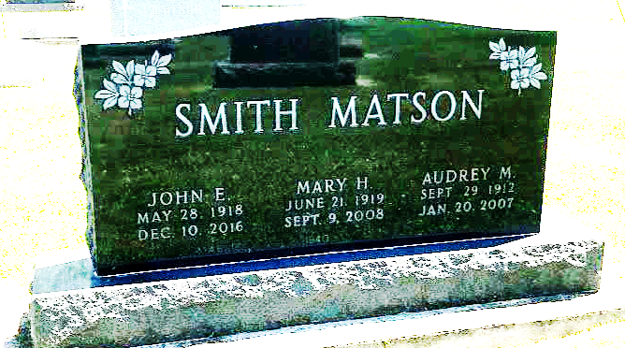
Photo by SMMR

Mary H. Smith, 89, Bluffton, died at 3:46 a.m. Tuesday, September 9, 2008 at Bluffton Regional Medical Center.
Born in Bluffton on June 21, 1919 to Frank and Jessie (Carlson) Matson, she married John E. Smith on Sept. 2, 1940 in Covington, Ky.; he survives.
A 1937 graduate of Bluffton High School, she worked as a book-keeper for the McDowell Lumber Co. for 22 years and for John Gallman for 20 years before retiring in 1980. She attended the Mulberry Street Wesleyan Church and served as the treasurer for the Wells County Historical Society for eight years.
Survivors, in addition to her husband of 68 years, include a sister, Dorothy (Paul) Gerwig of Bluffton. She was preceded in death by three sisters, Eva Shepherd, Marguerite Cash and Audrey Matson.
Calling hours are today from 2 to 8 p.m. at Thoma/Rich, Hewitt & Chaney Funeral Home and for one hour prior to the services Thursday, which will begin at 10 a.m. at the funeral home. Rev. Don Hosier will officiate. Burial will be in Faiview Cemetery. Preferred memorials are to the church.

Bluffton News-Banner, Wells County, Indiana
Wednesday, Sept. 10, 2008

