John E. Smith
May 28, 1918 – December 10, 2016

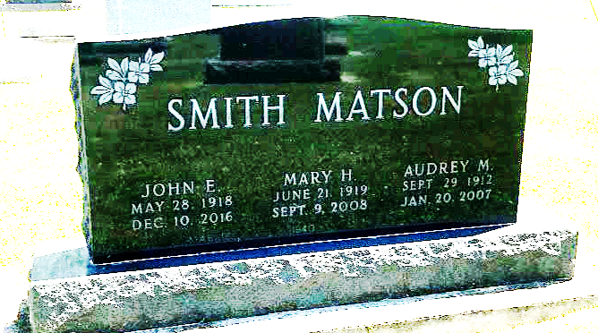
Photo by SMMR

John E. Smith, 98, of Bluffton passed away at 9:02 p.m. Saturday, December 10, 2016 at River Terrace in Bluffton.
He was born on May 28, 1918 in Frankfort, Indiana to John E. & Marie S. (Barton) Smith. John graduated from Bluffton High School in 1936, and worked for many years at McDowell Lumber Company in Bluffton. He also worked for 21 years as a group leader for Franklin Electric, retiring in 1981. He attended Mulberry Street Wesleyan Church, and currently a member of Epworth United Methodist Church and was a member of the Wells County Historical Society.
On September 2, 1940 in Covington, KY, John and Mary (Matson) were married. They were married for 68 years before she preceded him in death on September 9, 2008.
John is survived by a sister Beverly Niblick of Bluffton and four nieces, Gloria (Thomas) Mayne of Bluffton, Janet (Roy) Schoeff of Poneto, Doris Smith of Keystone and Cindy (William) Priester of Bluffton and a nephew Michael (Susan) Gerwig of Liberty Center.
He is preceded in death by his parents, wife Mary and a sister Nora Bishop.
Funeral services will be held at 11 a.m. on Wednesday (December 14, 2016) at the Thoma/Rich, Lemler Funeral Home in Bluffton. Tony Garton will officiate. Calling hours will take place from 9 to 11 a.m. on Wednesday, prior to the service. Burial will follow at Fairview Cemetery in Bluffton. Memorials: Epworth United Methodist Church or Family Life Care of Berne.
Thoma/Rich, Lemler Funeral Home, Wells County, Indiana
December 11, 2016

