H. Brooks Smith, M. D.
April 17, 1908 – October 18, 1948

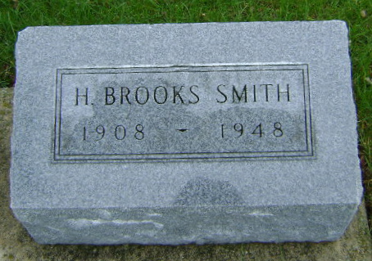
Photo by Bruce Sonner

Indiana, U.S., Death Certificates, 1899-2017
Name Brooks Smith
Gender Male
Race White
Marital Status Married
Age 40y 6m 1d
Birth Date 17 Apr 1908
Birth Place Fort Wayne, Allen, Indiana
Death Date 18 Oct 1948
Death Place Bluffton, Wells, Indiana, USA
Death Registration Date 1948
Father H Willard Smith
Mother Etta Breaks
Spouse Claudia Purkhiser Smith, age 36
Informant Mrs. H. Brooks Smith
Burial 10-20-1948 Fairview

