Claudia (Purkhiser) Smith
October 10, 1912 – December 20, 1995

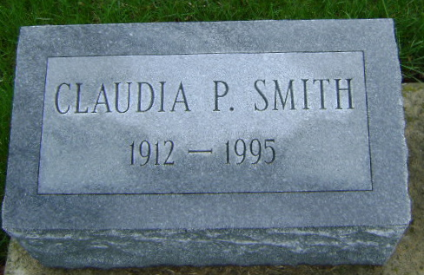
Photo by Bruce Sonner

Claudia P. Smith, 83, died at 3:30 a.m. today at Community Hospital where she had been a resident since August 1992. ??? an extended illness complicated by rheumatoid ?? lupus. Born ??, 1912 in Seymour, she was a daughter of Claude and Cordell Purkhiser. Her marriage Dec. 31, 1935 in ?? to Dr. H. Brooks Smith, who preceded her in death.
A graduate of Indianapolis Manual High School, she completed nursing at Wishard Memorial Hospital School of Nursing. She retired Jan. 1, 1976 after 12 years of service at ?? Hospital where she had served as a registered nurse ??? ward. A past president of Psi Iota Xi, she was ??? the First United Methodist Church. ??? in and did volunteer work for the Indiana ??? City.
Surviving are one son, Jon C. Smith of Bluffton; three brothers, ?? of Indianapolis, Knute Dobkins of Big Pine Key, ?? Dobkins of Phoenix, Ariz., a sister Mrs. Bernard ??? of Indianapolis; and two grandchildren.
Friends may call from 2 to 8 p.m. Thursday at Thoma/Rich, ?? Funeral Home, where rites will be officiated by ??? Humble at 1:30 p.m. Friday. Burial will be in Fairview Cemetery.

Berne (IN) Library Heritage Room
Misc. Death Book BB, image 61
Dec. 20, 1995—left side cut off
**
Indiana, U.S., Marriage Certificates, 1960-2012
Name Claudia Purkhiser
Marriage Date 31 Dec 1935
Marriage Place Marion, Union, Oregon, USA
Spouse H Brooks Smith
**
Social Security Death Index
Name Claudia P. Smith
Social Security Number xxx
Birth Date 10 Oct 1912
Issue year Before 1951
Issue State Indiana
Last Residence 46714, Bluffton, Wells, Indiana, USA
Death Date 20 Dec 1995
**

Claudia A Purkhiser Smith from tree SARVAY COCKLIN Family Tree
Birth 10 Oct 1912 Indiana, USA
Marriage 31 Dec 1935 Marion, Grant, Indiana, USA
Residence 1957 Bluffton, Wells, Indiana, USA
Death 20 Dec 1995 Bluffton, Wells, Indiana, USA
Father John Claude Purkhiser (1893-1919)
Mother Rebecca Emily Cordell (1893-1963)
Spouse Dr H Brooks Smith (1908-1948)
1514 People 9 Records 9 Sources

