Nellie May (Kahn) Smeltzer
March 15, 1904 – September 15, 1989

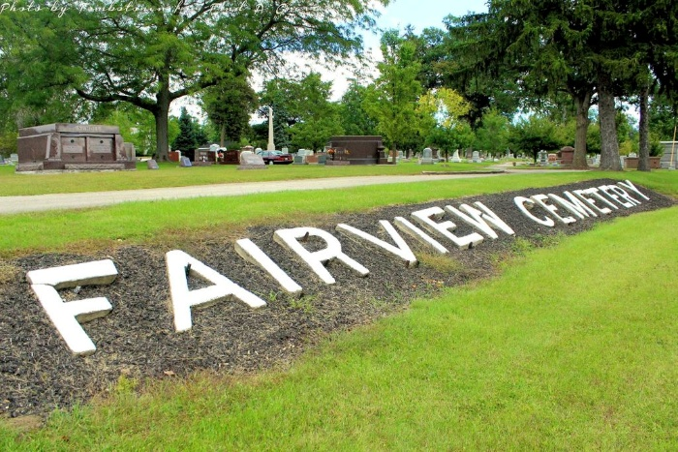
Photo by Tombstoner & Family

SMELTZER

Bluffton – Nellie May Smeltzer, 85, died at 2 pm Friday at home. She was a homemaker. Her husband, Edwin Sr., died in 1985.
Surviving are two daughters, Bonnie Ware and Barbara Edington, both of Bluffton; a son, Calvin E. of Bluffton; a brother; a sister; and 18 grandchildren.
Services at 1:30 pm Monday at Thoma/Rich Funeral Home; calling after 10 am Sunday. Memorials to the First Presbyterian Church.

Journal-Gazette, Allen County, Indiana
September 16, 1989, p. 5A
**

Indiana, U.S., Death Certificates, 1899-2017
Name Nellie May Smeltzer
[Nellie May Kahn]
Gender Female
Race White
Marital Status Widowed
Age 85
Birth Date 15 Mar 1904
Birth Place Kingsland, Indiana
Death Date 15 Sep 1989
Death Place Bluffton, Wells, Indiana, USA
Death Registration Date 1989
Father David Alonzo Kahn
Mother Catherine Dishong
Informant Bonnie Ware, daughter
Burial 9/18/1989 Fairview Cemetery

