Edwin R. Smeltzer, Sr.
September 12, 1903 – March 4, 1985

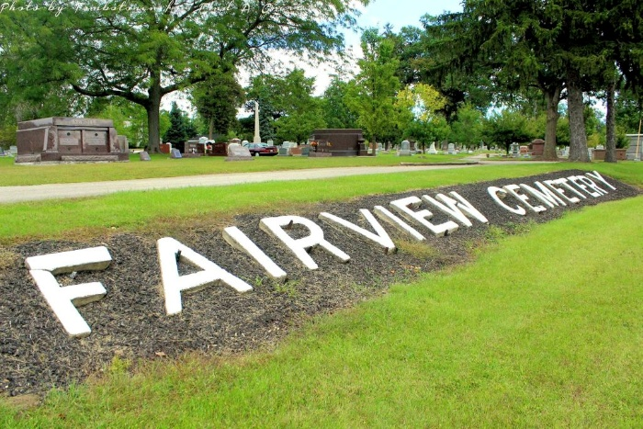
Photo by Tombstoner & Family

Indiana, U.S., Death Certificates, 1899-2017
Name Edwin R Smeltzer
Gender Male
Race White
Marital Status Married
Age 81
Birth Date 12 Sep 1903
Birth Place Pennsylvania
Death Date 4 Mar 1985
Death Place Bluffton, Wells, Indiana, USA
Death Registration Date 1985
Father Edwin R Smeltzer
Mother Ida May Wolf
Spouse Nellie M Smeltzer, informant
Burial Fairview 3/7/1985

