Mary Ann (Kirk) Small
April 12, 1929 – April 29, 2017

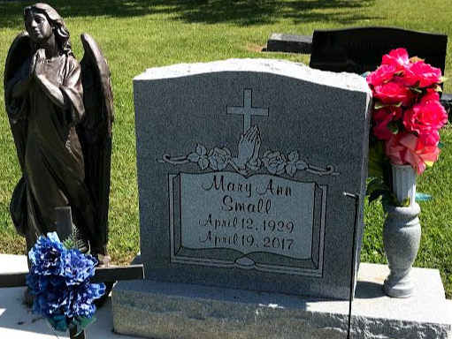
Photo by SMMR

Mary Ann Small, 88, of Bluffton passed away at 12:40 P.M. on Wednesday, April 19, 2017, at Signature Health Care in Bluffton, surrounded by her loving family. She was born on April 12, 1929 in Logansport, Indiana to Samuel Albert & Vera Dorothy (Fox) Kirk. She enjoyed spending time with her family and friends.
Survivors include her children: Jerry (LouAnn) Bosworth of Gas City, Sabrina (John) Vaughn of Bluffton, Alberta (Bruce) Hilton of Bluffton, Dorina J. Bosworth of Kentucky, Vera (Tim) Warnack of Bluffton and Jason (Lisa) Small of Montpelier. She is also survived by 19 grandchildren and many great-grandchildren and a sister Linda.
She is preceded in death by a son Edward Bosworth, along with two great-great grandchildren and three brothers and two sisters.
Funeral services will be held at 10:30 A.M. Monday (April 24, 2017) at the Thoma/Rich, Lemler Funeral Home in Bluffton. Rev. Lakeya Stewart will officiate. Burial will follow at Fairview Cemetery in Bluffton. Calling hours will be held from 1 to 6 P.M. on Sunday at the funeral home and for one hour prior to the service on Monday. Memorials may be made to Heart to Heart Hospice.

Thoma/Rich, Lemler Funeral Home, Wells County, Indiana
April 20, 2017

