Richard L. Sills
May 31, 1929 – November 13, 2009

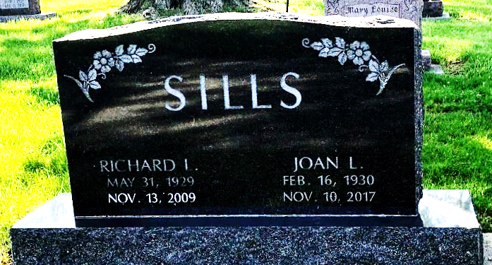
Photo by SMMR

Richard L. Sills, 80, of Bluffton, passed away peacefully Friday, Nov. 13, 2009. He passed away peacefully, surrounded by his family. Mr. Sills was born May 31, 1929, in Bluffton, to James and Alvena (Graham) Sills. He was a 1947 graduate of Bluffton High School where he was active in all sports. He received the Robert Baumgartner award. He attended Wabash College. He married Joan (Moser) in Bluffton on July 10, 1949, and celebrated their 60th wedding anniversary this past summer.
In 1996 he retired from the Cline Kitchen Center in Bluffton. He had a 38-year career designing and installing kitchen cabinets for Lynn Koehlinger, Broadway Lumber, Swisher Lumber, and Cline Lumber. He was in the U.S. Navy Reserve from 1955 to 1959. He was a member of the First Baptist Church where he served on several boards and committees and was a Sunday school teacher. He was also a longtime member of the Lions Club. He was an avid golfer, belonging to Timber Ridge Golf Course. He was very proud of his four holes-in-one.
He is survived by his wife, Joan, of Bluffton; two daughters, Kathi (Dave) Hartman of Marion and Karen (Kevin) Reed of Bluffton; two sons, Rick (Cheryl) Sills of Bluffton and Ted (Karen) Sills of Decatur; and 13 grandchildren and 12 great-grandchildren.
He was preceded in death by a daughter, Kris Barger, and a sister, Ramona Miller.
Calling hours are 2 to 8 p.m. Tuesday at the Thoma/Rich, Chaney & Lemler Funeral home and from 9:30 to 10:30 a.m. Wednesday at First Baptist Church. Funeral services will be at 10:30 a.m. Wednesday at the First Baptist Church with Pastor Bud Abrams officiating. Burial will be at the Fairview Cemetery.
Preferred memorials are to the First Baptist Church, Family Hospice and Palliative Care, and Christian Care.
Thoma/Rich & Lemler Funeral Home, Wells County, Indiana

