Joan L. (Moser) Sills
February 16, 1930 – November 10, 2017

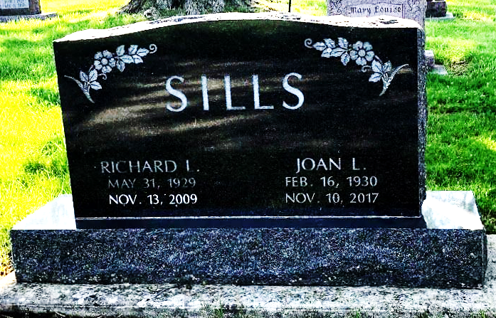
Photo by SMMR

Joan L. Sills, 87, of Bluffton passed away on Friday, November 10, 2017, at Christian Care Retirement Community in Bluffton.
She was born on February 16, 1930 in Bluffton, Indiana, to Dennis and Mabel (Gerber) Moser. She graduated from Bluffton High School in 1948. Joan worked at Miller Airport and retired from Kitco.
Joan enjoyed vacationing in Michigan, participating in the covered bridge festivals and the Blueberry Festival. Joan was noted to never say “No” to babysitting.
On July 10, 1949 in Bluffton, Joan and Richard L. Sills were married. They celebrated their 60th wedding anniversary before he preceded her in death on November 13, 2009. Joan was a member of the First Baptist Church, a longtime member of Tri Kappa.
She is survived by two daughters, Kathi (Dave) Hartman of Fort Wayne and Karen (Kevin) Reed of Bluffton; two sons, Rick (Cheryl) Sills of Bluffton and Ted (Karen) Sills of Decatur; and 13 grandchild-ren and 18 great-grandchildren.
She is survived by a sister, Doris (Larry) Hall of Alma, MI, along with a nephew, Christopher Hall in Hong Kong.
She was preceded in death by a daughter, Kris Barger.
Calling hours are 2 to 8 p.m. Monday at the Thoma/Rich, Lemler Funeral home and from 9:30 to 10:30 a.m. Tuesday prior to the service. Funeral services will be at 10:30 a.m. Tuesday (Nov. 14, 2017) at the Thoma/Rich, Lemler Funeral Home with Pastor Les Cantrell officiating. Burial will follow at the Fairview Cemetery.
Preferred memorials are to the Christian Care Retirement Center.
Thoma/Rich & Lemler Funeral Home, Wells County, Indiana
November 11, 2017

