Dennis James Siela
February 20, 1959 – May 16, 1972
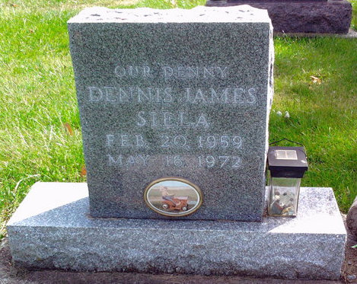
Photo by Thomas Liby
Bluffton boy, mauled by dog dies at hospital
FORT WAYNE, Ind. (UPI)—Dennis Siela, 12, Bluffton, died Tuesday night at Parkview Hospital here of dog bites suffered a week earlier.
Hospital officials said young Siela, who has been in critical condition since being bitten by a St. Bernard May 9 while on a field trip with his seventh grade class, died from the massive abrasions on his head, neck and shoulders. The boy was the son of Mrs. Naomi Siela, Bluffton.
Authorities said they had not located the dog which attacked the boy, but they added they believed they knew the owner.
The boy is survived by his mother, Mrs. Naomi Yake-Siela; two sisters, Miss Debbie Siela, a student at the Indiana University Medical Center at Indianapolis, and Miss Deanna Siela, at home, and the paternal grandmother, Mrs. Emma Siela of Bluffton route 1. The boy’s father, Leo F. Siela, Jr., died in 1966.
Funeral services will be held at 10 a.m. Friday at the Craigville United Methodist church, with Rev. Paul Fulp officiating. Burial will be in Fairview cemetery at Bluffton. Friends may call at the Thoma funeral home after 7 p.m. today.

Decatur Daily Democrat, Adams County, Indiana
Wednesday, May 17, 1972

