Martha E. Shigley
May 2, 1892 – October 2, 1911

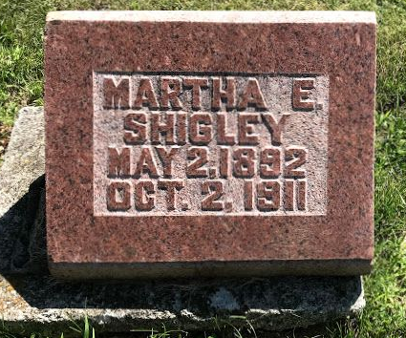
Photo by SMMR

Mr. and Mrs. J. M. Rose, Miss Lizzie Rose, and Mr. and Mrs. John Shigley were in Bluffton Wednesday to attend the funeral of their niece and granddaughter, Martha Shigley, who died after a short illness of but a few hours with acute indigestion and paralysis of the heart. She is a daughter of George Shigley and is known to several in Berne having visited here at different times.
L. O. Shigley, of Kokomo, who attended the funeral of his niece at Bluffton, Wednesday, is visiting here with his parents, the aged Mr. and Mrs. John Shigley.

Berne Witness, Adams County, Indiana
Friday, October 6, 1911
**

Indiana, U.S., Death Certificates, 1899-2017
Name Martha Huph Shigley
[Martha Huph Shigeley]
Gender Female
Race White
Marital Status Single
Age 19y 5m 0d
Birth Date 2 May 1892
Birth Place Bluffton, Wells County, Indiana
Death Date 2 Oct 1911
Death Place Bluffton, Wells, Indiana, USA
Father George D Shigley, informant
Mother Vena Hupp
Burial Fairview Cem 10/4/1911

