Lewis D. Shiere
August 12, 1871 – May 23, 1940

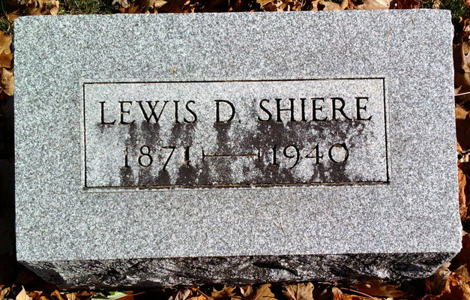
Photo by Thomas Liby

Bluffton, May 23 – Lewis L. Shiere, 68, suffered a fatal heart attack at 11 am today while working in his grocery here. Coroner William Gitlin investigated.
Surviving are the widow, Adah; a stepson, Robert Davis of Bluffton; a step daughter, Mrs. Wendell Plummer of Elgin, Ill., and two brothers, Harry Schiere of Bluffton and Charles Shiere of Hartford City.
The body will be removed Friday morning from the Thoma Funeral Home to the residence. Funeral services will be held at the Thoma Chapel at 2 pm Saturday, in charge of Rev. Morris Coers of the First Baptist Church, and interment will be in Fairview Cemetery.

Journal-Gazette, Allen County, Indiana
May 24, 1940
**

Indiana, U.S., Death Certificates, 1899-2017
Name Lewis D Shiere
Gender Male
Race White
Marital Status Married
Age 68y 9m 11d
Birth Date 12 Aug 1871
Birth Place Bluffton, Wells, Co Indiana
Death Date 23 May 1940
Death Place Bluffton, Wells, Indiana, USA
Death Registration Date 1940
Father Wm Shiere
Mother Mary Ann Hudson
Spouse Adah Dailey Shiere, informant
Burial Fairview Cem. 5/25/1940

